|  |
| --- |
| [Team 25] |
| < SLO Wayfinding >  Proposal and Planning |
| [Student Life Office] |
|  |
| **Nate Chiang**  **Castiel Li**  **Ron Tran**  **Quincy Lam** |

**Table of Contents**

1. Document Version 3

2. Introduction 3

2.1. Purpose 3

2.2. Team contact information 3

2.3. Description 3

3. Project Proposal 3

3.1. Existing System 3

3.2. Proposed Solution 3

3.3. Diagrams/ Analyses 3

3.4. Alternative Solutions 3

3.5. Technology 3

3.6. Deliverables 4

4. Stages Plan 4

# Document Version

|  |  |  |  |
| --- | --- | --- | --- |
| **Version** | **Description** | **Date** | **Author(s)** |
| **1** | Created | 30/09/2017 | Castiel Li |

# Introduction

## Purpose

* A web application that presents all BCIT Student Services currently provided for student who is unfamiliar about those services. In the meeting, we were told that many BCIT students did not access all the services they needed. One of the reason is because the current BCIT website split those services into many sub sessions. This is great for presenting detailed information to students, however, it also makes access overall information about all the service difficult.
* The BCIT Student Life Office (SLO) wants to make this web application to raise student’s awareness about BCIT Student Services. Also, with part-time students and new students, who cannot make it on orientation day, they can use this app to get information about all of services that are available in BCIT.
* The web application will be very simple and easy to use. User will be able to access all basic information regarding the services. (Operation hours, contact information, location etc) In addition, if student would like to learn more detail of those service, we will provide the link from BCIT website for them to visit.

## Team contact information

TEAM 25

Supervisor: Donna Turner

|  |  |  |
| --- | --- | --- |
| Member Name | Email address | Phone |
| Castiel Li (Project Manager) | castiel.andrew@gmail.com |  |
| Quincy Lam | [quincylam@hotmail.com](mailto:quincylam@hotmail.com) | 604-319-8830 |
| Nate Chiang | [chonjou@gmail.com](mailto:chonjou@gmail.com) | 604-704-5442 |
| Ron Tran | [ronnotran97@gmail.com](mailto:ronnotran97@gmail.com) | 604-441-3645 |
| Donna Turner (Supervisor) | dturner80@bcit.ca |  |

## Description

* A web application that presents all BCIT Student Services currently provided for student who is unfamiliar about those services. In the meeting, we were told that many BCIT students did not access all the services they needed. One of the reason is because the current BCIT website split those services into many sub sessions. This is great for presenting detailed information to students, however, it also makes access overall information about all the service difficult.
* The BCIT Student Life Office (SLO) wants to make this web application to raise student’s awareness about BCIT Student Services. Also, with part-time students and new students, who cannot make it on orientation day, they can use this app to get information about all of services that are available in BCIT.
* The web application will be very simple and easy to use. User will be able to access all basic information regarding the services. (Operation hours, contact information, location etc) In addition, if student would like to learn more detail of those service, we will provide the link from BCIT website for them to visit.

# Project Proposal

## Existing System

The existing system is BCIT welcome page (<https://www.bcit.ca/welcome/>). The website contains many detailed information about student services that is being provide by BCIT; however, due to the huge amount of information. Student found it difficult to learn all the service they can access as well as just some basic information about those services. The current WayFinding Guide(<https://www.bcit.ca/files/lifeatbcit/pdf/student-services-wayfinding-guide-2017.pdf>) is great in term of giving students a brief description of each services in BCIT. However, it does not have the information student would need for accessing those service. (Operation hours, Contact information etc).

The new system we are building will have some details of each service which just enough for them to access the services they need.

## Proposed Solution

We decided to create a single page web application to solve the problem. We will use the category icons that provided by SLO as our main page. When a user clicks on them, all the services that are part of the category will be displayed. When the user clicks on one of those services, it will display some basic information (brief description, operation time, location, website and a student video that provided by SLO office. There will be also a search bar where students can search for the service they were looking for. Our intent is to give student a shortcut/gateway to access the services they need; therefore, we will contain our page within three clicks.

## Diagrams/ Analyses

Since the Project is relatively small. I believe the following prototype is easier to understand than a UML diagram.

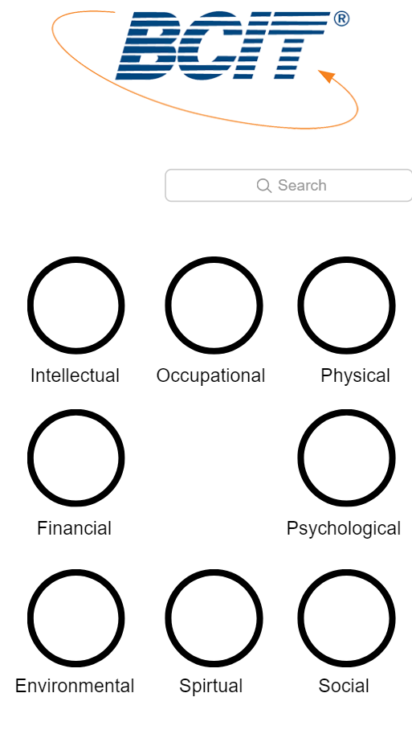  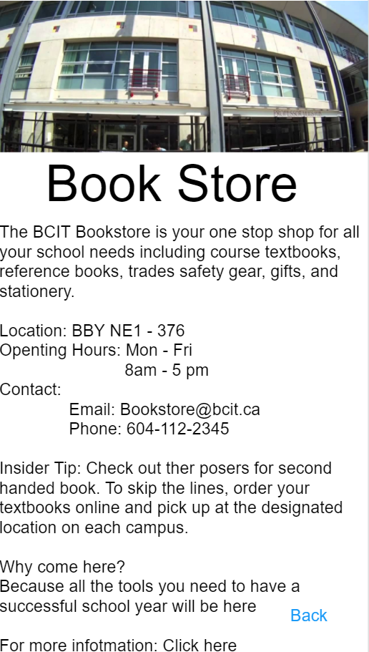

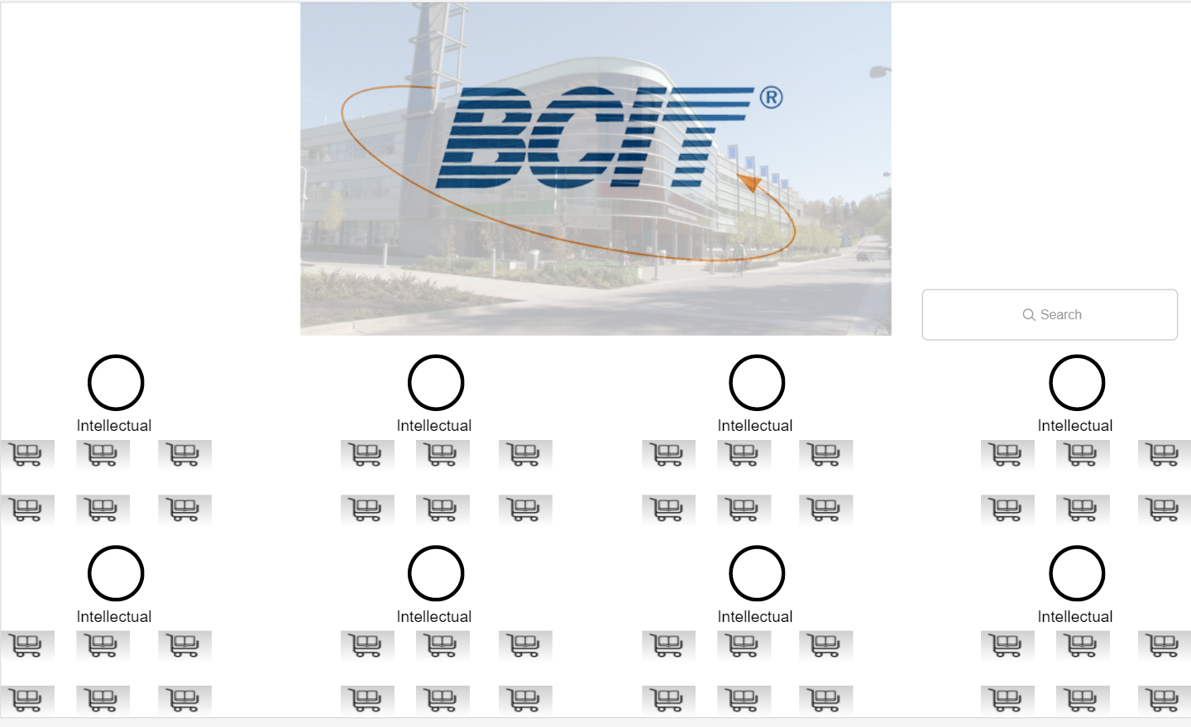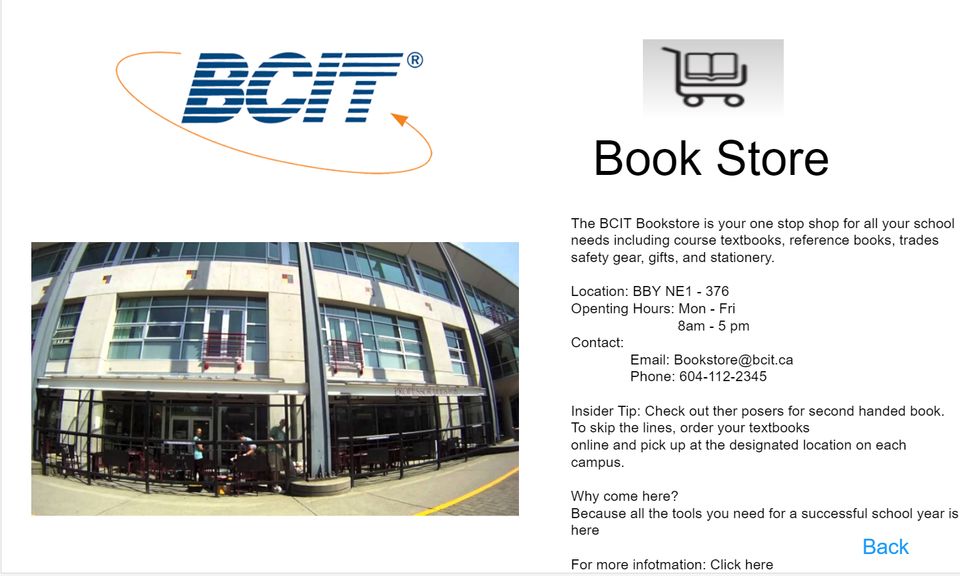

## Alternative Solutions

* Create a blog page allow students to post question they wanted to be answer by other students
* Create a student guiding tour of the services
* Create a virtual map of BCIT Burnaby campus

## Technology

For this project, we are decided to use React.js as our main scripting language. We will also use CSS, HTML, and one of the database. We have not yet decided on what database we will be using now. React is the best fit for our single page application, it loads everything at once and displays information base on the filter we provided. We will be able to speed up the loading time for the application by a significant amount of time. Since there might be many pics being implement in the future and this will be a handy informational website, the fast loading speed will help us improve user experiences.

## Deliverables

|  |  |
| --- | --- |
| **Deliverable** | **Description** |
| UI/UX design | The team will provide the client with a design that will is consisted of three panels on desktop and a singular one in mobile. |
| Front end of the application | The team will also oversee the development of the UI/UX design. |
| Responsiveness on the latest device on Android and iOS | The team will focus their efforts on two devices one for each operating system. The team will not try to achieve responsiveness on every device and every browser, only the most common ones. |
| Easy method to change the data in the future | Since the information may need to update on regularly base, we will make sure the process of updating information is easy and fast. |

# Stages Plan

|  |  |  |
| --- | --- | --- |
| Stage | Work Plan | Accomplish |
| 2 | Build up all the elements for the web application and testing | A working web application with all the place holder |
| 3 | Add content, polish the UI, and testing | Have a web application fully functional |
| 4 | More polishing, maybe add new feature and testing | Depends when we finish the fully functional product. We may add the student tour guide feature. |

The client does not have a preference as how we go about our work. Therefore, we will make our own plan for the remaining three stages.